**Educational Objective:**

Excel is widely used for plotting in industry because of its simplicity and availability. This lab’s objective is to refresh your knowledge needed for plotting with Excel.

**Pre-Laboratory:** No pre-lab. All future labs will have a pre-lab.

**Procedure:**

Note: All future labs will have a quiz available for the first ten (10) minutes of your laboratory session. The content of the quizzes will be based on the knowledge you gain while completing the pre-lab section of the laboratory activity. You will be able to use your pre-lab as a reference while taking any lab quiz.

**Work alone – no partners allowed on this lab.**

Section 1: Excel data tables and plotting.

1. 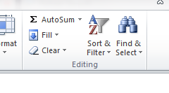*Working with Excel to create a data table*:
   1. Figure 1-1 provides actual measured data of a diode.
   2. Enter the Voltage column into Excel using the procedure below:
      * Enter the title column, V (volts)
      * Enter zero and then select 15 cells. Do not type each voltage.
      * Select “Fill” and “Series” from the home tab. Enter a 0.05 step value and voltage will be filled in for you.

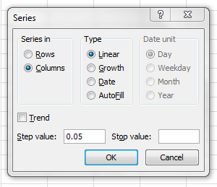

|  |  |  |
| --- | --- | --- |
| V(volts) | V2 (volts) | I (mA) |
| 0 | 10 | 0 |
| 0.05 | 15 | 0 |
| 0.1 | 20 | 0.001 |
| 0.15 | 25 | 0 |
| 0.2 | 30 | 0.001 |
| 0.25 | 35 | 0.003 |
| 0.3 | 40 | 0.005 |
| 0.35 | 45 | 0.02 |
| 0.4 | 50 | 0.04 |
| 0.45 | 55 | 0.1 |
| 0.5 | 60 | 0.2 |
| 0.55 | 65 | 0.5 |
| 0.6 | 70 | 2 |
| 0.65 | 75 | 5 |
| 0.7 | 80 | 14 |

Figure 1-1

* 1. Figure 1-1 also includes a V2 column just for fun. Use the fill procedure to populate this column – DO NOT ENTER EACH VALUE, let Excel do it for you using the series function.
  2. 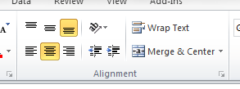Enter the Current title and data. Each value must be entered in this case because there is no pattern.
  3. Select all the data and center it using the Home tab’s Alignment tool.
  4. 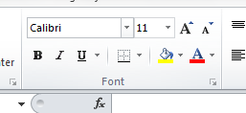Use the Home tab’s border tool to add a border to the data so the table looks similar to table 1.

1. *Working with Excel to make a plot:*
   1. Select the Insert tab.
   2. First plot V2 vs V (volts).
      * Select the V and V2 columns.
      * Select Scatter and the option without the curve (just points). Easily changed later. A plot will be quickly created like in Figure 1-2.

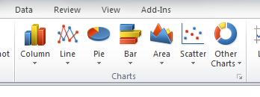

Note: When plotting data, Scatter is almost always used. A common mistake is to use Line which equally spaces each data point. A simple rule: always use Scatter.

Figure 1-2

* 1. What values are used for Y can be easily modified. To do this:
     + Click on the Plot.
     + Select the Design Tab and then click on Select Data.
     + Click on the Y value “V2” and then Edit.

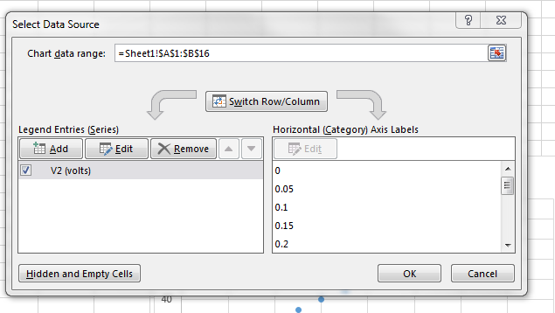

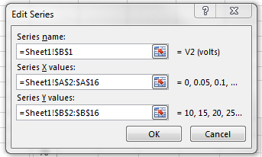

* + - Delete the entry in the Series name: box and select the top cell of I (mA) instead.

Note: The Series name: will now be “=Sheet1!$C$1”. Sheet1 is the worksheet we are working on but could be from any sheet in the workbook. The $ in front of the row and column letters/numbers anchor the selection so it does not move if the selection is copied.

Note: You can edit the text in selection box. In the next step you will be asked to edit the text instead directly to change the plot.

* + - Edit the Series Y values: changing both “B”s to “C”s. The plotted data should change to I (mA) as shown in Figure 1-3.

Note: So hopefully it is clear that the X and Y data and titles can come from anywhere on a sheet or even from other sheets in your Excel workbook.

Figure 1-3

* 1. With the plot selected, click on the Design ribbon and then select “Layout 6” from the Quick Layout menu in Chart Layouts.
     + Change the chart title so it describes the Y and X data. All plots must have a title with Y listed first.
     + Change the Axis Titles. All plots must have Axis Titles that include units.
     + Remove the legend.
     + Make the plot look like figure 1-4 and obtain a sign-off.

Figure 1-4

* 1. Show your instructor your graph and obtain a **sign-off**. To make it easier to submit your sign-offs in your report, a single sign-off page is included at the end of this lab.

Section 2: Excel plotting equations.

1. *Using equations in Excel. Specifically plotting Shockley’s equation:*

Note: This section will focus on a silicon diode with a 0.7V forward voltage. As you will see the actual voltage where current starts to flow (the forward voltage) is somewhere between 0.6V and 0.7V. The forward voltage is an important diode specification and can be readily found on the diode’s datasheet.

Background from Wikipedia:

### Shockley diode equation

The *Shockley ideal diode equation* or the *diode law* (named after [transistor](http://en.wikipedia.org/wiki/Transistor) co-inventor [William Bradford Shockley](http://en.wikipedia.org/wiki/William_Shockley)) gives the I–V characteristic of an ideal diode in either forward or reverse bias (or no bias). The *Shockley ideal diode equation* is below, where n, the ideality factor, is equal to 1:

I=I_\mathrm{S} \left( e^{V_\mathrm{D}/(n V_\mathrm{T})}-1 \right),\,

where

*I* is the diode current,

*I*S is the reverse bias [saturation current](http://en.wikipedia.org/wiki/Saturation_current) (or scale current),

*V*D is the voltage across the diode,

*V*T is the [thermal voltage](http://en.wikipedia.org/wiki/Thermal_voltage), and

*n* is the *ideality factor*, also known as the *quality factor* or sometimes *emission coefficient*. The ideality factor *n* typically varies from 1 to 2 (though can in some cases be higher), depending on the fabrication process and semiconductor material and in many cases is assumed to be approximately equal to 1 (thus the notation *n* is omitted). The ideality factor does not form part of the *Shockley ideal diode equation*, and was added to account for imperfect junctions as observed in real transistors. By setting n = 1 above, the equation reduces to the *Shockley ideal diode equation*.

* 1. Select the + button on the bottom of the workbook. A new sheet will be displayed. Right click on the Sheet2 tab and select Rename. Change the sheet name to something more meaningful than Sheet2 as shown below.

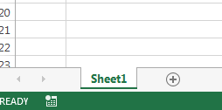

* 1. Create a section in the new sheet for the equation constants: Is, n and VT as shown in figure 1-5. A typical value for “Is” is 1 pA. This value is entered by typing 1e-12. The typical values for n and Vt should also be used as shown in figure 1-5. The cell locations are referenced later in the procedure so make sure you put Is in Cell A1, n in Cell A2 and so on.

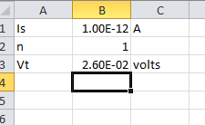

Figure 1-5

* 1. Create a table with a column for diode voltage and diode current. Use the “fill” function to create the diode voltage column starting at 0V, ending at 0.8V in 0.02V increments (the sample in the figure below only shows part of the data stopping at 0.14V, you will go to 0.8V). The note below offers some advice to make this step easier.

Note: When using the fill function you might not know how many cells you need to fill. Start with a few as shown in figure 1-6. Move the cursor to the bottom right corner of the selection until the cursor becomes a skinny +. Click and drag the downward. Excel will continue filling with the correct increment as you increase the size of the data table. Excel will also show the last value it is entering so you know when to stop.

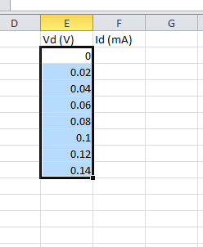

Figure 1-6

* 1. Using Shockley’s equation have Excel calculate the current in the diode. To do this follow the steps below.
     + Select the first cell in the current column. Cell F2 in figure 1-6
     + Type =
     + Select the cell with the value of Is. Cell B1 in figure 1-5. Press F4 to add a $ before the column name and row number.

Note: The $ anchors the cell so it will be used even if the formula is copied to a different cell in the worksheet. The anchors become essential when entering the same equation for multiple cells. Using anchors the cell can be copied but the anchored cells will still be used.

* + - Enter the rest of the equation pressing F4 after selecting the n and Vt cells. Your formula should look like the one below. Do not anchor (press F4) the diode voltage, Vd. Each calculation of Id will use a different value of Vd. Make sure you include lots of paratheses.

=$B$1\*(EXP(E2/($B$2\*$B$3))-1)

* + - Select the cell. Click on the lower right corner and drag downward. Excel will automatically copy your formula. Verify the equation in cell F3 is:

=$B$1\*(EXP(E3/($B$2\*$B$3))-1)

Note: Non-anchored references like E3 change from E2 when you copy down one row. $B$1, $B$2 and $B$3 stayed the same.

* + - Create a plot. Label the axis and title. Get a sign off.

Section 3: Checking your equipment.

1. *Follow the procedures in Appendix A to check your DMM and Power Supply. I strongly suggest following the procedure in Appendix A each time you come to lab.*
   1. Show your instructor how you verify the DMM current capability and obtain a **sign-off**.

Section 4: Building automated measurement circuits. Working alone! Each person must build their own schematic and breadboard layout.

The first new IC is the op-amp shown in figure 4-1. The second is the resistor SIP pack shown in figure 4-2. We will use two SIP packs.

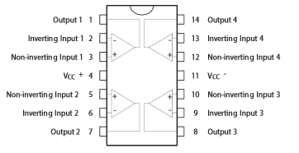

Figure 4-1

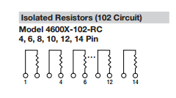

Figure 4-2

1. *Create a schematic and breadboard layout.*
   1. Create a schematic for the circuit shown in figure 4-3 in MultiSim. See the next page for parts.

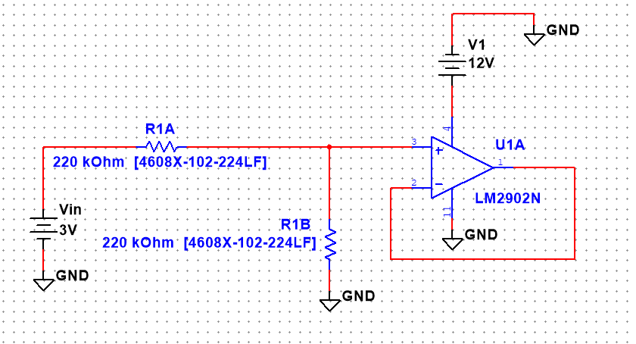*Figure 4-3*

* + - Use the LM2902N from the Analog library for the op-amp.

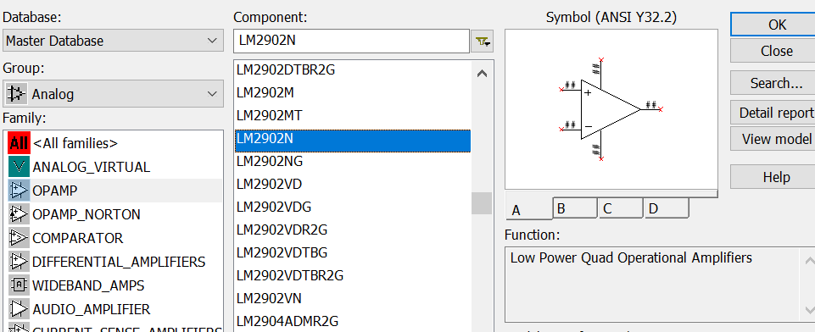

There are four op-amps in the chip. Select “A”.

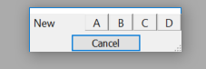

* + - Use the 220 kOhm [4608X-102-224LF] resistor network for R1A and R1B.

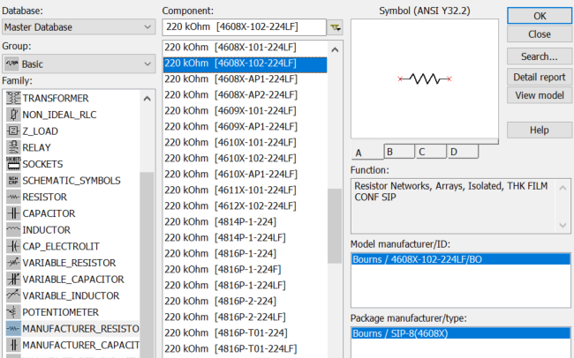

There are four resistors in the chip. Select “A” for R1A.

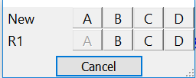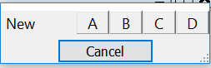 *and then “B” for R1B*

* 1. Wire the breadboard by selecting **View Breadboard** in the **Tools** menu.
     + Under Options select Breadboard Properties and select 2 slats.

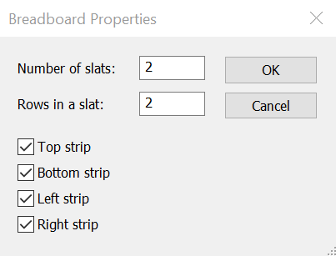

* + - Drag and place the batteries to the back slat (breadboard) as shown.

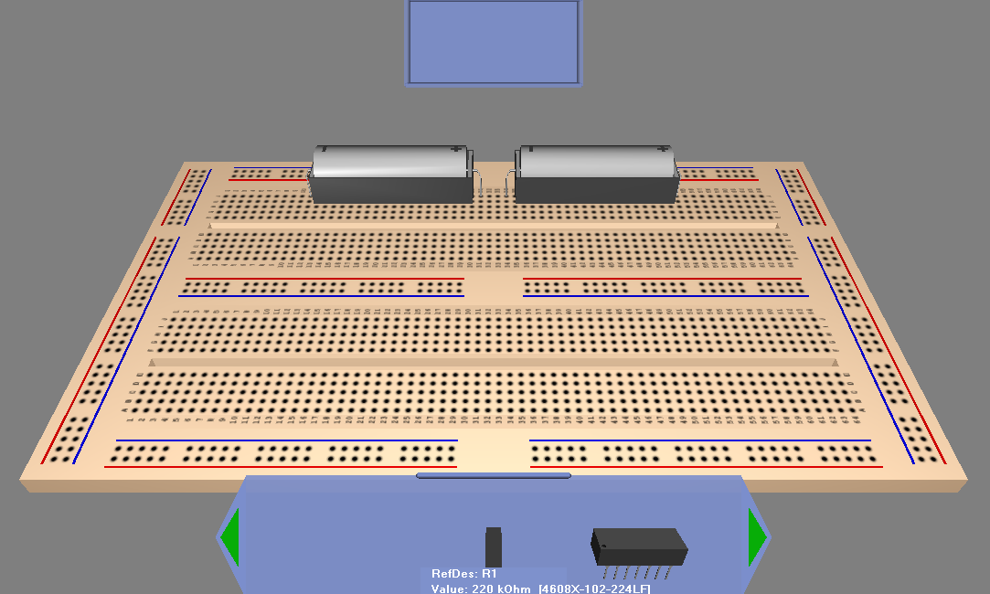

* + - Place the other components on the front breadboard and wire the breadboard.
    - Requirements:
      1. No crossing wires.
      2. Use red and blue buses for power. Beware! They are broken in the center.
      3. Run DRC and Connectivity Check under Tools menu with no errors.
      4. Print completed breadboard image for next section.
    - Helpful hints:
      1. When a wire is started, its correct ending location will be displayed.
      2. As wires are added to the breadboard, they become green in the schematic. Change back and forth to view your progress.
      3. Use mouse wheel to zoom in and out.
      4. Press down on mouse wheel to pan.
      5. Mouse changes between pointer (select), wire segment (wiring) and rotation depending on its location in the window.
      6. Use CTRL-R to rotate parts.

Section 5: Building automated measurement circuits. Working alone! Each person must build their own schematic and breadboard layout.

Note: Future labs will utilize circuit built during this lab. The circuit will allow us to automate some measurements so repetitive measurements are not required.

1. *Construct the following circuits.*
   1. Construct the circuit shown in figure 4-3 on your own breadboard. The following rules apply to this and all future builds:
      * All wires must lay flat on the board.
      * No arching wires and all wires MUST lay flat.
      * Wires are not to cross over one another.
      * Verify all components. In this case the SIP pack will have a 224 in their part number signifying 22 and 4 zeros or 220,000 or 220Kohms. The IC will have a 2902 in its part number.
      * **DO NOT TAKE THE CIRCUIT APART. IT WILL BE USED IN LATER LABS.**
   2. Obtain a sign-off.

**Sign-offs:**

Section 1: Diode Current vs. Diode Voltage Plot

|  |  |  |
| --- | --- | --- |
|  |  | / / |
| Signature |  | Date |

Section 2: Shockley’s equation

|  |  |  |
| --- | --- | --- |
|  |  | / / |
| Signature |  | Date |

Section 3: Checking your Equipment

|  |  |  |
| --- | --- | --- |
|  |  | / / |
| Signature |  | Date |

Section 4: MultiSim Circuit Build

|  |  |  |
| --- | --- | --- |
|  |  | / / |
| Signature |  | Date |

Section 4: Real Circuit Build

|  |  |  |
| --- | --- | --- |
|  |  | / / |
| Signature |  | Date |

**Report: Due next lab period.**

1. Submit a cover page with name and major
2. Signed pages
3. Full-page plots of both diode curves. Avoid these common mistakes:
   1. Putting the dependent variable on the wrong axis. The one you adjust or control is the dependent variable. It always goes on the x-axis.
   2. Forgetting to include units with your x and y axis.
   3. Forgetting to add a title which is usually stated y vs. x.
   4. Making your graph too small. This lab requires a full page plot.

**Appendix A: Checking the DMM (digital multi-meter)**

Note: A large amount of time can be wasted with either broken meters or more likely broken test leads. Broken equipment in a co-op or full-time position may cause you to make incorrect or embarrassing assumption. The next few steps will show you how to verify the DMM. You might repeat all or some of these steps before each lab to ultimately save time.

* 1. **Test your DMM leads. Broken leads are common.**
     + Set the DMM to measure resistance.
     + Touch the leads (figure A-1) together and verify that the resistance is very small.
     + Put a little stress on the leads by bending them and make sure the resistance stays small.
     + If the resistance stays under a few ohms the probes are in working order.

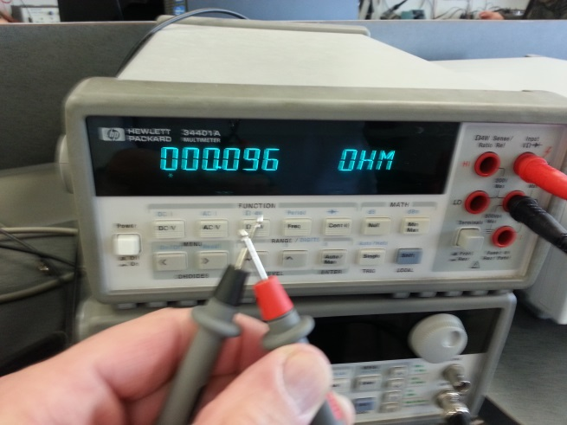

Figure A-1

* 1. **Test the power supply and DMM current setting.**
     + Set the DMM to measure DC current and move the red test lead to the lower right plug (figure A-2).

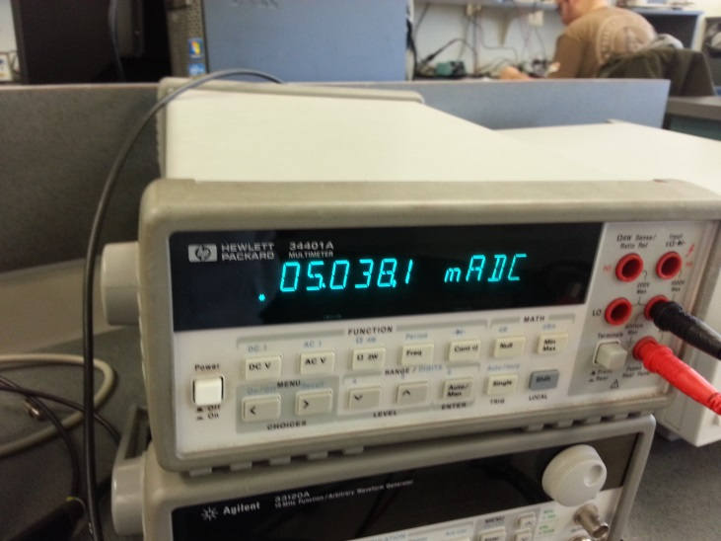

Figure A-2

* + - Turn on the power supply and adjust the output to 5V (figure A-3).
    - Attach a 1K resistor to the red probe and insert it into the red side of Output 1. Insert the black probe into black side of Output 1. See figure A-3.
    - Verify approximately 5 mADC as shown in figure A-2. If the current is near zero: 1) Verify the power supply settings (next step), then 2) check the DMM fuse and finally 3) recheck the DMM probes.
    - Verify the settings for CH1 shown in the lower left side of the screen are 5V and at least 0.5A but no more than 1A.

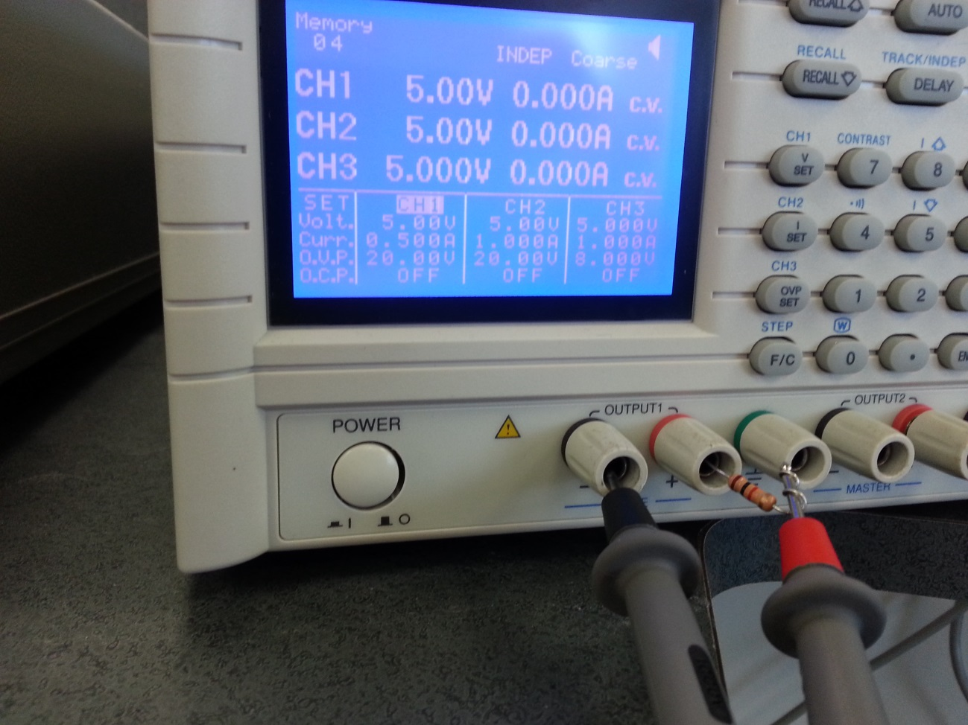

Figure A-3

* 1. **Test the DMM voltage setting. Good last step so probes are put back in voltage and resistance measuring position.**
     + Set the DMM to measure DC voltage and the power supply to output 5V.
     + 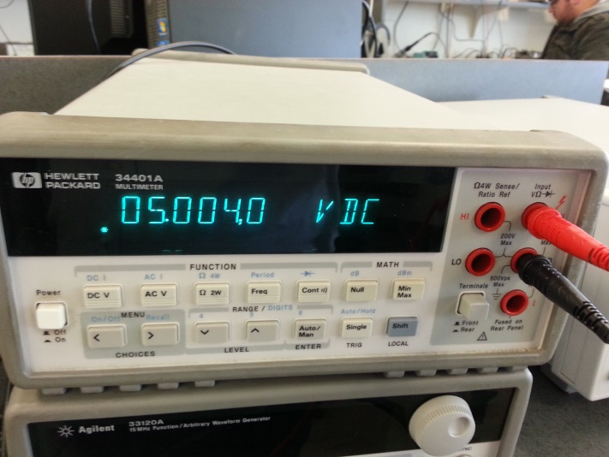Verify the 5V output as shown the pictures below (figure A-4).

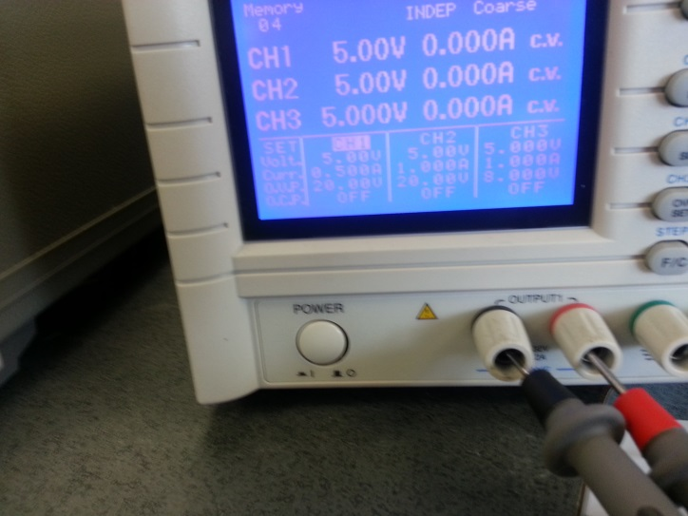

Figure A-4